# GIT

# 1.Git-HOL

# Mandatory HandsOn

**Step 1: Setup your machine with Git Configuration**

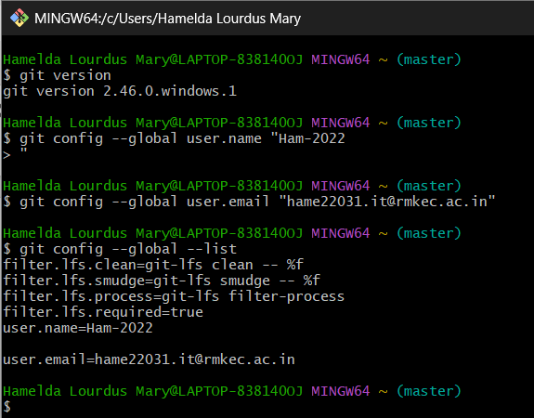

**Step 2: Integrate notepad++.exe to Git and make it a default editor**

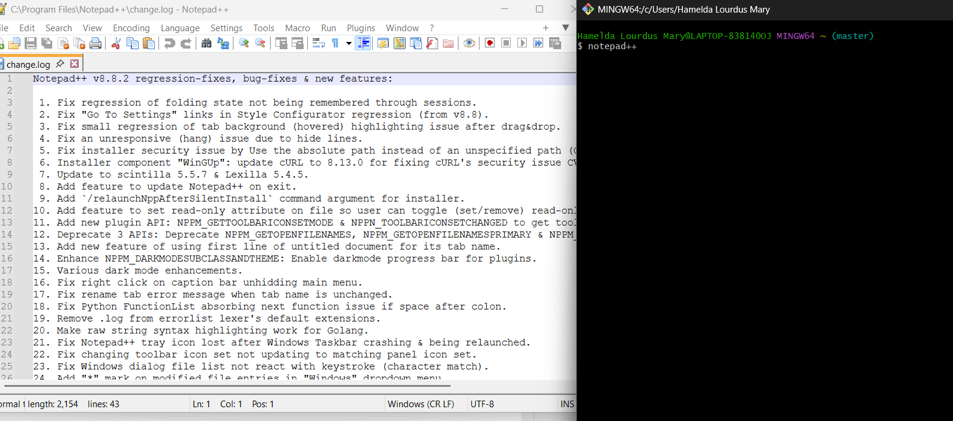

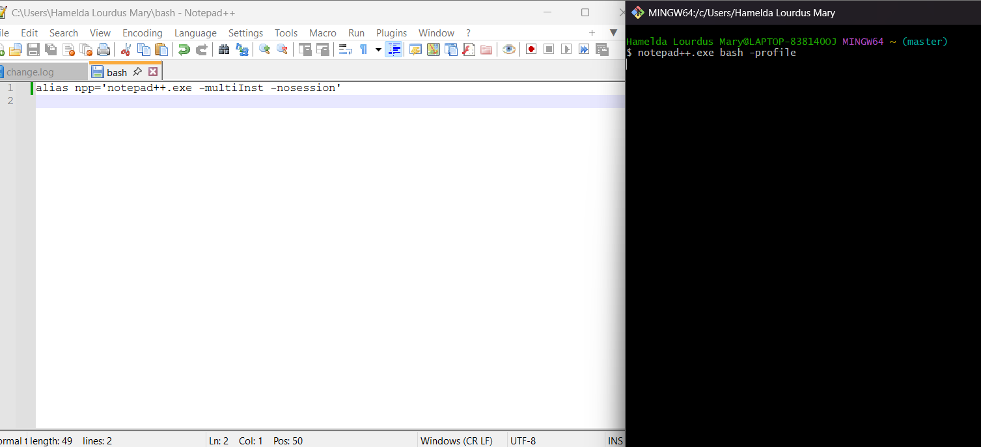

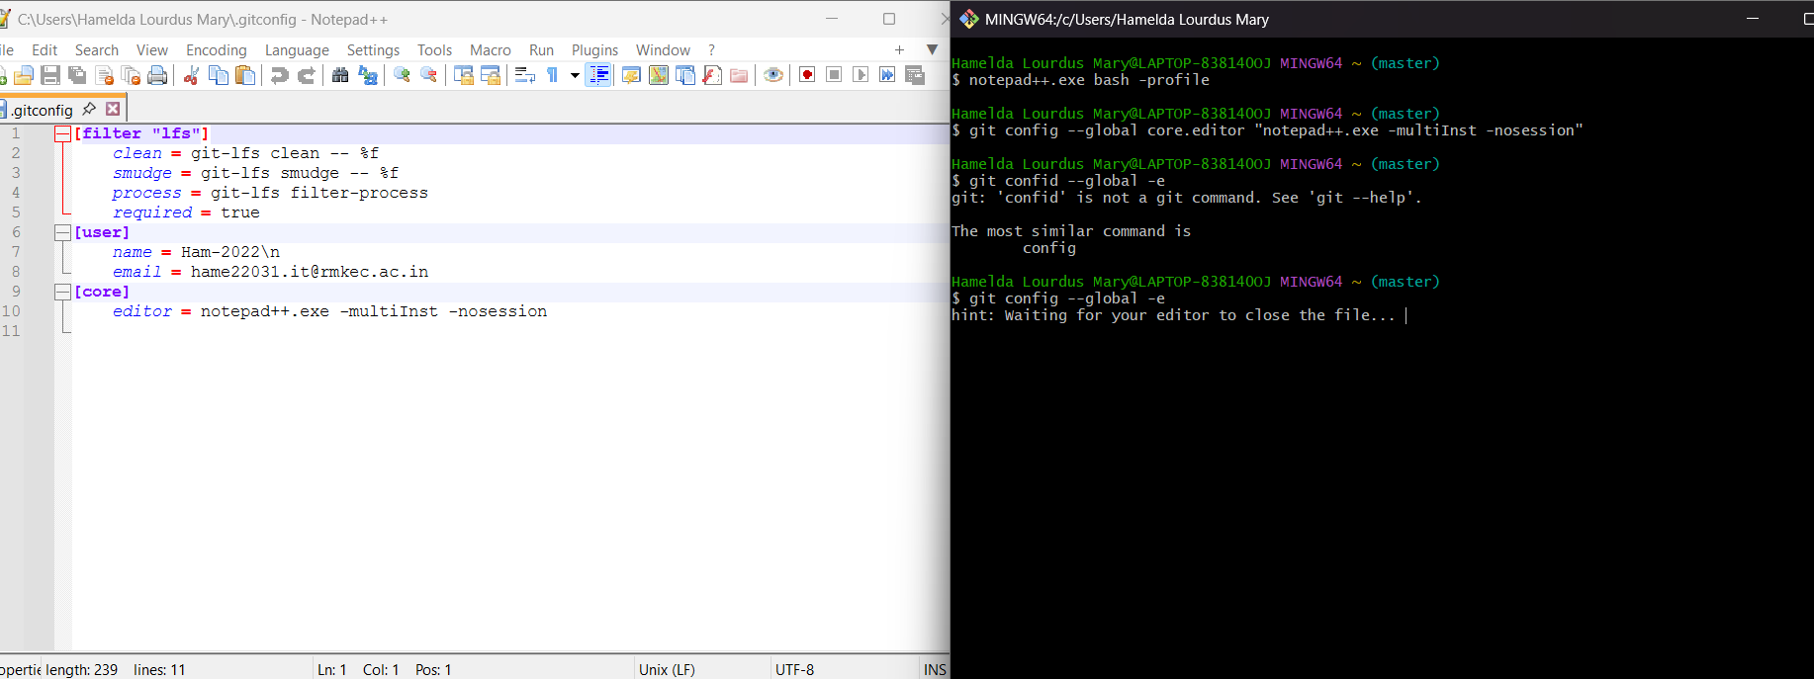

**Step 3: Add a file to source code repository**

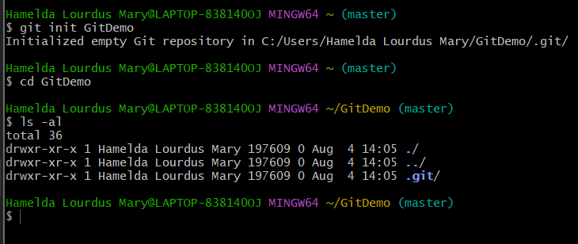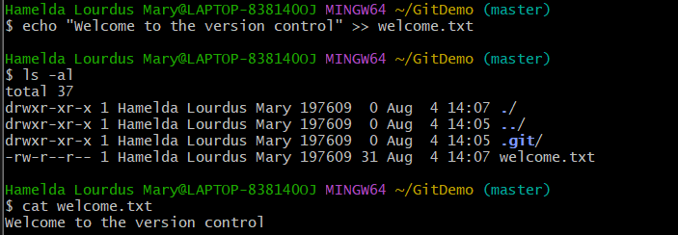

To check if local and “Working Directory” git repository are same, execute git status

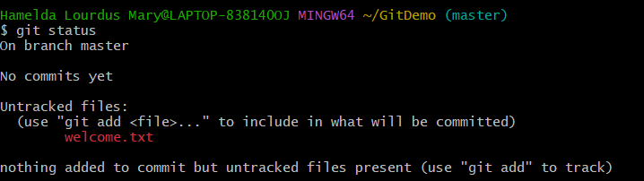

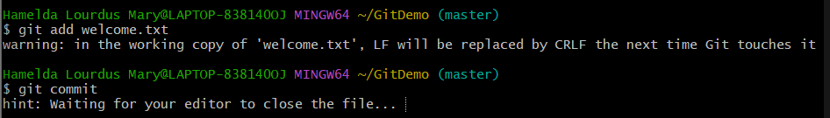

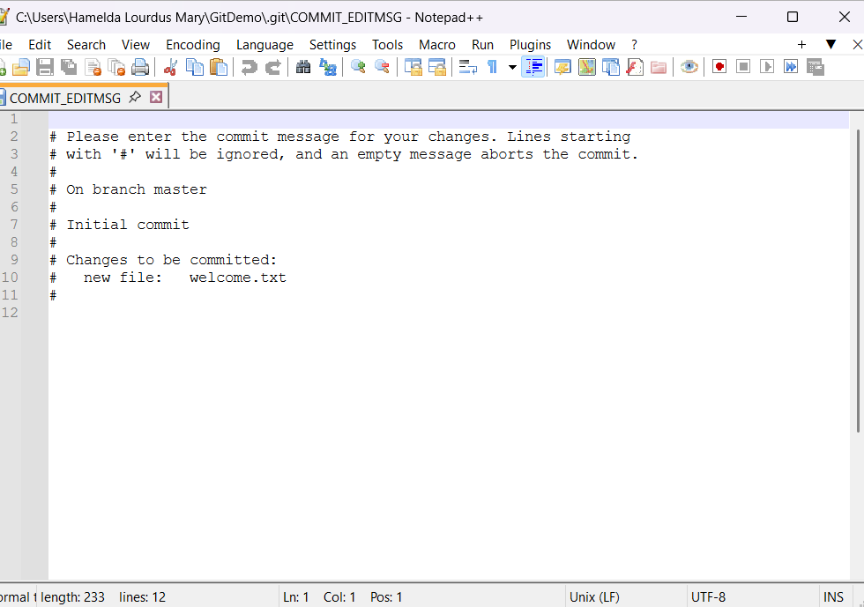

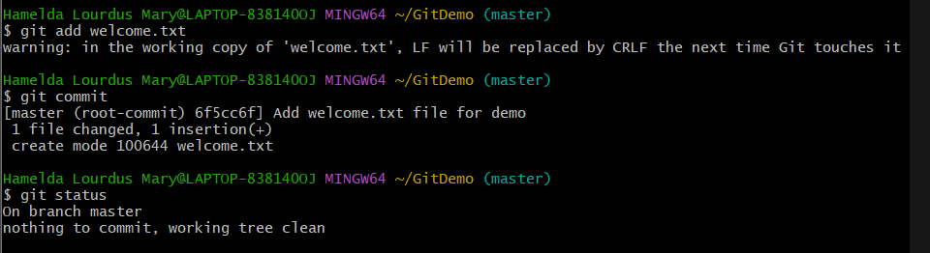

* Signup with GitLab and create a remote repository **“GitDemo”**
* To pull the remote repository, execute

git pull origin master

* To push the local to remote repository, execute

git push origin master

